**Name – Parag Gattani**

Program No. – 09

Program Title – PIR

**AIM**

Demonstrate to show working of PIR sensor.

**HARDWARES REQUIRED**

* Arduino Board
* PIR sensor
* Resistor
* LED pin
* Breadboard Small

**CIRCUIT DIAGRAM**

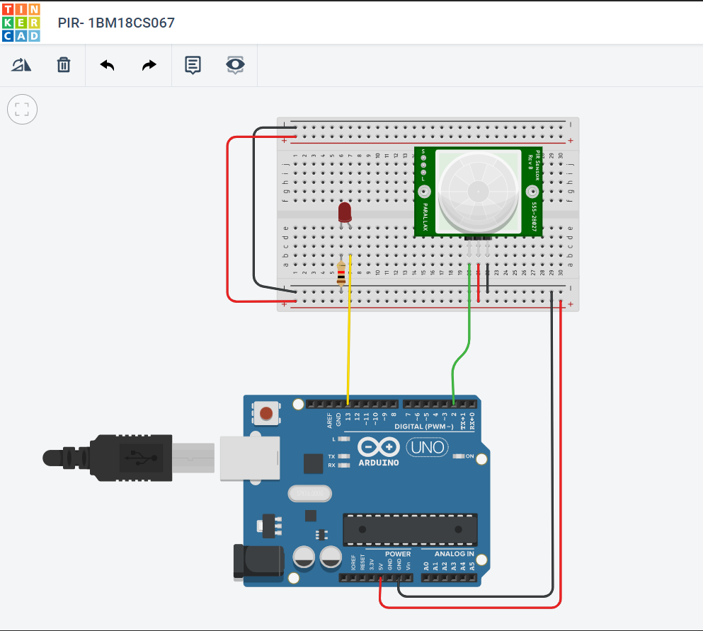

**WRITE-UP**

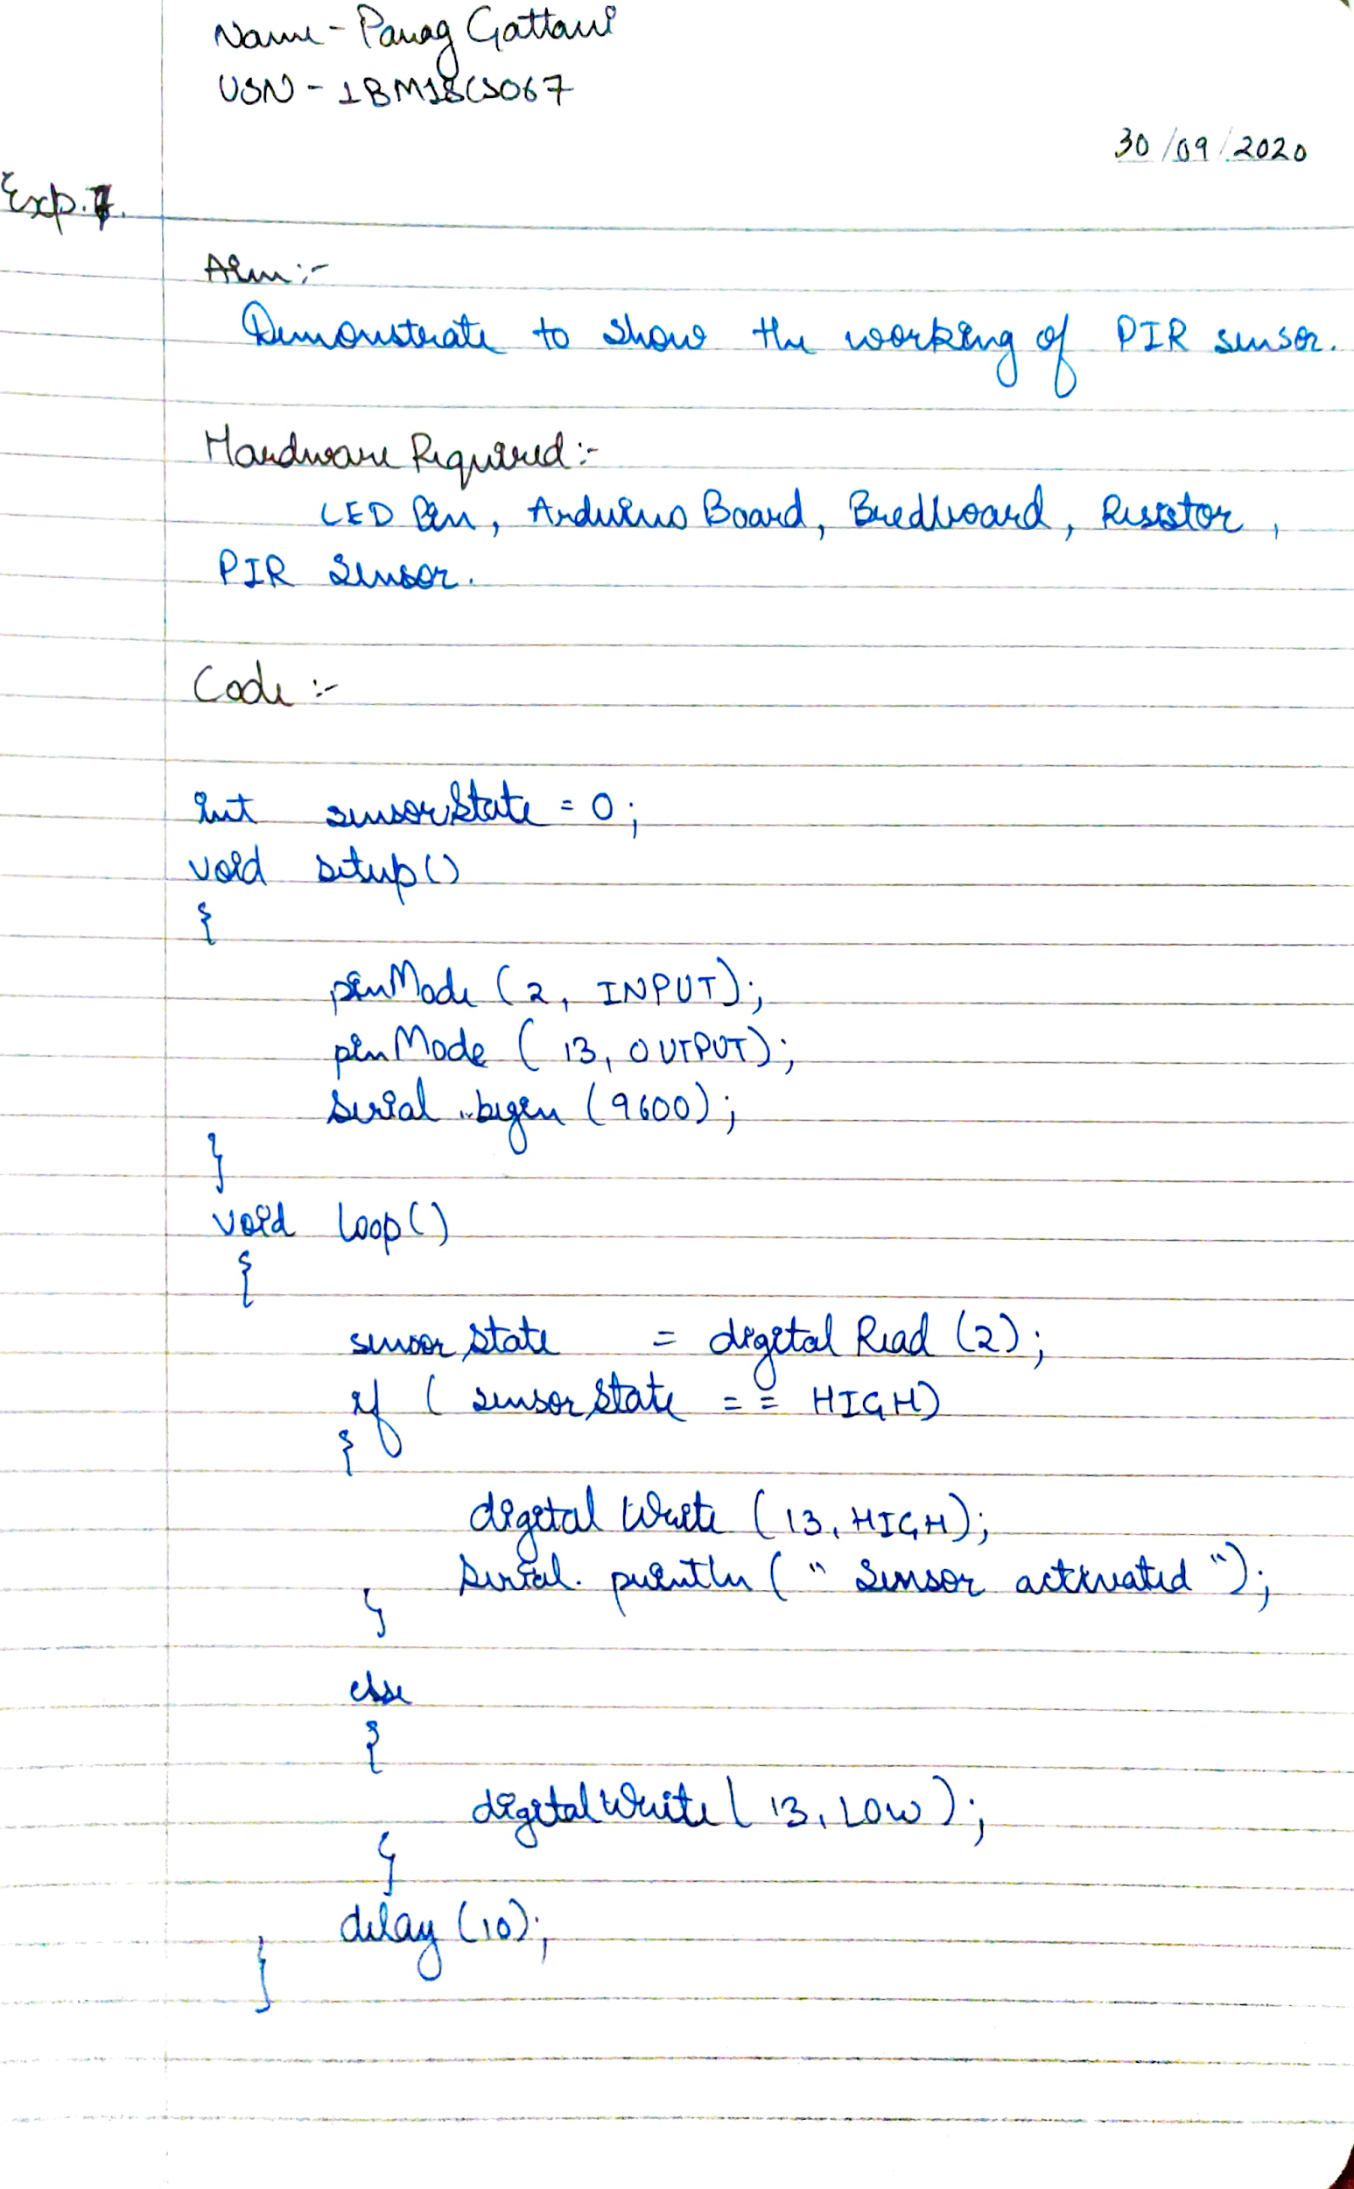

**CODE**

int sensorState = 0;

void setup()

{

pinMode(2, INPUT);

pinMode(13, OUTPUT);

Serial.begin(9600);

}

void loop()

{

sensorState = digitalRead(2);

if (sensorState == HIGH) {

digitalWrite(13, HIGH);

Serial.println("Sensor activated!");

} else {

digitalWrite(13, LOW);

Serial.println("Sensor deactivated!");

}

delay(5); }

**OUTPUT**

Designed a system to show working of PIR Sensor.